[GOOGLE EARTH ENGINE](EE01%20Earth%20Engine%20(EE).docx) [GRAPHICAL USER INTERFACE](EE02%20%20%20The%20EE%20GUI.docx)

**CAPABILITIES**

The Graphical Users Interface (GUI) of Google Earth Engine (EE) offers seven types of capability that are highly interrelated

yet useful to distinguish from one another in learning how to use this software. These include capabilities associated with

- the **Execution** of GUI instructions,

- the **Navigation** of geographical space,

- the **Acquisition** of datasets,

- the **Generation** of data layers,

- the **Computation** of data layers,

- the **Presentation** of data layers, and

- the **Reproduction** of data layers

[GOOGLE EARTH ENGINE](EE01%20Earth%20Engine%20(EE).docx) [GRAPHICAL USER INTERFACE](EE02%20%20%20The%20EE%20GUI.docx)

**CAPABILITIES**FOR THE **EXECUTION** OF INSTRUCTIONS

**Execution** capabilities are those that offer “control of the controls.”

The EE GUI is controlled by way of an application window that can be directed to any one of

three web pages, each responding to user input through onscreen buttons or fields. These include

- a **Home** page that introduces this application,

- a **Data Catalog** page through with particular online datasets can be loaded, and .

- a **Workspace** page through which loaded datasets can be displayed or downloaded, as can the results of specified computations applied to those data.

At any given moment, the Workspace page of the EE GUI will list the layers that are associated with whatever datasets are currently loaded and whatever computations have been applied to those layers. It will also display these layers according to whatever visualization settings have been specified. Thus, the state of that Workspace page at any given moment is, in itself, the primary work product generated by this GUI. Though downloads and displays may also be regarded as significant work products, it is only the Workspace page that lends itself to the full range of future processing opportunities. It is for this reason that the EE GUI

makes it possible to record and reset the state of a Workspace page in any of several ways. All are invoked by clicking on this **Manage workspace** button on the Workspace page. This will open a menu of five buttons,

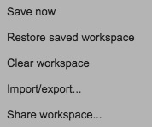 each affecting the manner in which the EE GUI is controlled.

This records the current state of the Workspace page

and associates it online with the current EE GUI user.

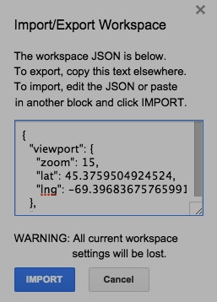 This sets a Workspace page to the state most recently saved

by the current EE GUI user in this or any prior session.

This resets the current Workspace

page to its original “empty” state.

This either writes a set of instructions describing the current state of the Workspace

page or reads a set of instructions describing how to reset the state of that page.

These instructions are given in JSON (JavaScript Object Notation) format and stored

as text that can be copied to/from a specified text file to/from a dialog box like this.

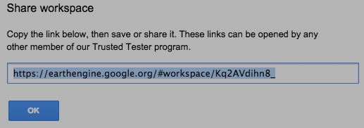

This presents a web address

that can be used by any

authorized EE user to

open a copy of the EE GUI

and direct it to a copy of

the current Workspace page.

[GOOGLE EARTH ENGINE](EE01%20Earth%20Engine%20(EE).docx) [GRAPHICAL USER INTERFACE](EE02%20%20%20The%20EE%20GUI.docx)

**CAPABILITIES**FOR THE **NAVIGATION** OF GEOGRAPHICAL SPACE

The geospatial **navigation** capabilities of the EE GUI enable the Display Screen on the Workspace page’s to - focus on a particular region of the globe, and

- depict that region with any of several types

of general-purpose cartographic material.

To zoom in on the Display Screen and thereby narrow its geographical extent while increasing its detail,

drag or scroll upward on this slider control. To zoom out, do just the opposite.

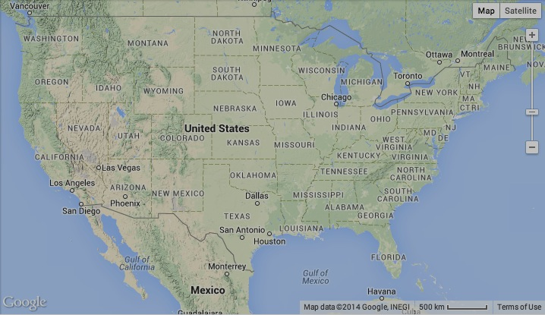 To change the background of the Display Screen from (or to)

this **Map** format to (or from) this **Satellite** format, use these buttons .

To add topographic relief shading

to the Map format, checkmark

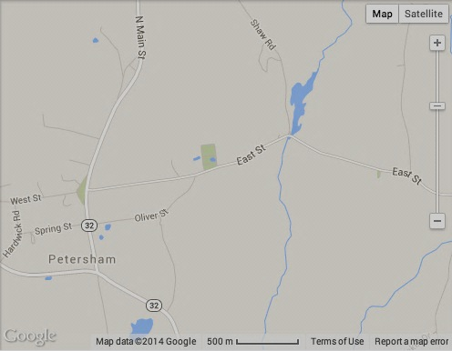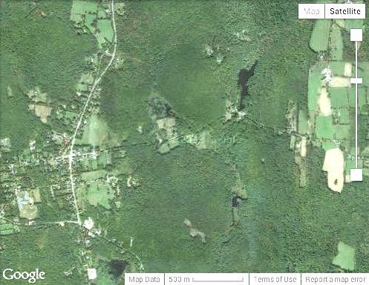this **Terrain** option after hovering

over the Map button.

And to add labels to the Satellite

format checkmark this **Labels**

option after hovering

over the Satellite button.

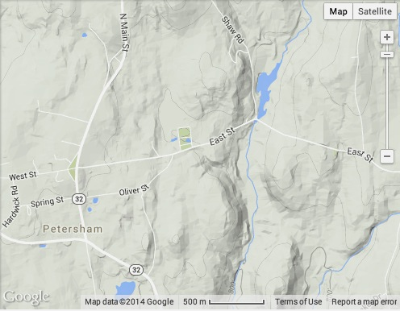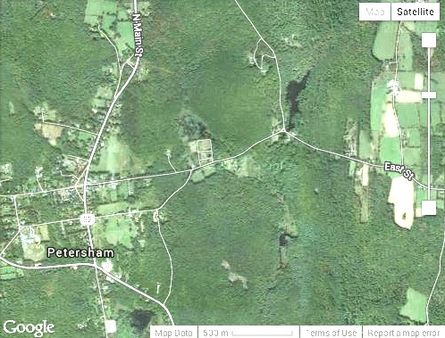



[GOOGLE EARTH ENGINE](EE01%20Earth%20Engine%20(EE).docx) [GRAPHICAL USER INTERFACE](EE02%20%20%20The%20EE%20GUI.docx)

**CAPABILITIES**FOR THE **ACQUISITION** OF DATASETS

****Data **acquisition** capabilities are those that read/write data from/to web-accessible

files called **Datasets** to/from onscreen depictions of those datasets called **Layers**.

In particular, these include capabilities that

- add online datasets from the Data Catalog to the Workspace page as layers, and

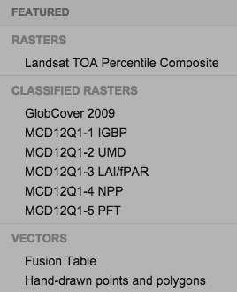- remove layers from the Workspace page.

Datasets in the Data Catalog are most often found and added to the Workspace page by way of this **Search Bar**

that appears at the top of all EE GUI pages. A click in the **Search Places, Keywords, Table, or Asset IDs …** field here

will open a listing of several selected datasets, any of which can be added clicking on its name as listed here.

The same came also be done by clicking on the Workspace page’s **+** or **Add data** buttons.

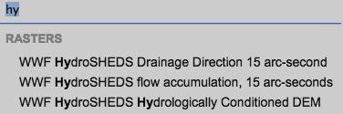

Additional datasets can be sought by entering text into

the **Search Places, Keywords, Table, or Asset IDs …** field.

In this case, all available datasets with names that match

(or partially match) this text will be listed as shown here

and can be added to the Workspace page clicking on their names.

Selected datasets that are listed on the Data Catalog page can also be added by using one of

the **Open in workspace** buttons on that page or on any of those on its dataset-specific subpages.

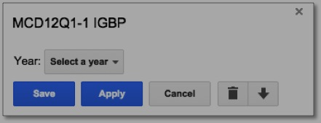



For multi-temporal layers, it will also be necessary to select a date

in the **Layer Settings** dialog box for each layer.

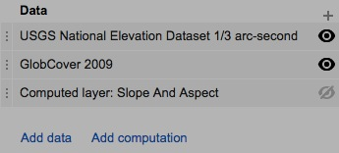

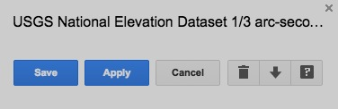

To remove a layer from the **Workspace** page, click on

its name the **Data** section of that page’s **Control Panel**

to open its **Layer Settings** dialog box, then click on

this **Delete layer** button.

[GOOGLE EARTH ENGINE](EE01%20Earth%20Engine%20(EE).docx) [GRAPHICAL USER INTERFACE](EE02%20%20%20The%20EE%20GUI.docx)

**CAPABILITIES**FOR THE **GENERATION** OF DATA LAYERS

Among the layer **generation** capabilities of the EE GUI are - those that upload offline datasets from private sources to the Workspace page as layers,

- those that create a special kind of layer by onscreen digitizing.

User-supplied data representing vector-baaed features (but not raster-based images)

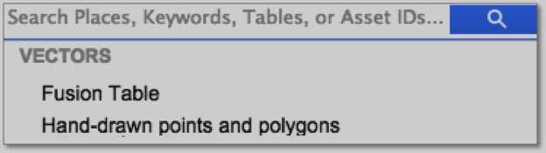 can be uploaded to the EE GUI by using Google **Fusion Tables**, experimental

application for the online visualization and sharing of large sets of both public and

private data in tabular form. With **Fusion Tables**, data in the form of points, lines,

polygons, street addresses, and geographical place names can used to generate

cartographic layers compatible with Google Earth and Google Earth Engine. For more

information, check out <https://support.google.com/fusiontables/answer/184641>.

The onscreen drawing capabilities of EE are invoked by clicking on the Search Bar and then on this **Hand-drawn points and polygons** button.

At least one class must then be added to the Workspace page, however, before any drawing will be allowed.

To draw multiple points, click on

To draw a point, click on this **Add a marker** button this “padlock” button to “lock” it

in the Display screen’s upper left corner, then click before placing points. Then click on

on the screen wherever the point is to be placed. this **Exit** button when done.

****To delete a drawn point, click on this **Stop drawing** button, To reposition a drawn point, just drag

then on the point to be deleted, then this **Delete** button it to its new position before clicking on

and, when done deleting one or more, click on **Exit**. **Exit**.

To draw a polygon, click on this **Draw a shape** button, To draw multiple polygons, click on

then click on the Display Screen to draw the vertices the padlock button to before placing

****around that polygon before double-clicking on vertices and, when done, click on

its final vertex. **Exit**.

****To delete a drawn vertex, click on this **Stop drawing** button, To reposition a drawn vertex, just drag

then on the vertex to be deleted, then this **Delete** button it to its new position before clicking on

and, when done deleting one or more, click on **Exit**. **Exit**.

To delete or reposition an entire polygon, click on the **Stop drawing** button, then inside the polygon, then **Delete** or drag, and **Exit**.



The layer created by onscreen drawing will ultimately be listed here

on the Workspace page, where it can be managed like any other layer.

[GOOGLE EARTH ENGINE](EE01%20Earth%20Engine%20(EE).docx) [GRAPHICAL USER INTERFACE](EE02%20%20%20The%20EE%20GUI.docx)

**CAPABILITIES**FOR THE **COMPUTATION** OF DATA LAYERS

Layer **computation** capabilities provide for the creation of new layers from existing layers by way of specified calculations. This is done by clicking on the

**Add computation** button on the Workspace page (which will be available only to authorized users) and the selecting one of ten particular types of computation.

****Each will create in a “computed layer” whose Layer Settings dialog box will offer computational settings that will vary

from one type computation to another but will always require that computation and visualization be applied, saved, cancelled,

or deleted.



That Layer Settings dialog box will also offer these buttons

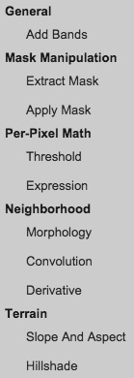with which multiple-step computations can be constructed.

The ten types of computation available are as follows.

**Add Bands** creates a new layer by merging bands that are drawn from existing layers

**Extract Mask** creates a new layer from the mask band of an existing layer.

**Apply Mask** creates a new layer by using a drawn rectangle, a drawn polygon, or the mask band of an existing layer.

**Threshold** creates a new layer by setting one or more specified ranges of value on an existing layer to a specified value.

**Expression** creates a new layer by applying algebraic functions to the value(s) of each pixel to an existing layer.

**Morphology** creates a new layer by applying functions to the values of each pixel’s neighbors to an existing layer.

**Convolution** creates a new image by summing to the values each pixel’s neighbors on an existing layer

after multiplying each neighboring value by a coefficient associated with its neighborhood position.

**Derivative** creates a new layer of the differences between each pixel’s value and

those of its horizontal and vertical neighbors on an existing later.

**Slope and Aspect** creates a new layer by computing each pixel’s slope and aspect on an existing layer of elevation values.

**Hillshade** creates a new layer by computing each pixel’s topographic shading on an existing layer of elevation values.

[GOOGLE EARTH ENGINE](EE01%20Earth%20Engine%20(EE).docx) [GRAPHICAL USER INTERFACE](EE02%20%20%20The%20EE%20GUI.docx)

**CAPABILITIES**FOR THE **PRESENTATION** OF DATA LAYERS

With the **presentation** capabilities of the EE GUI, you can control - the degree to which all or part of and given layer is visible on the Display Screen,

- the range of colors used to represent the range of values on a non-classified raster layer, and

- the particular colors used to represent particular values on a classified raster layer.

To control the order in which layers appear to be above or below

one another other on the Display Screen, drag their names in the To make a layers appear either visible of invisible, click on

Layer List names to the desired order by dragging up or down on this **Eyeball** buttons to the far right of its name.

these **Handle** buttons to the far left of each name.

A non-classified raster layer is one whose values represent continuous quantities (such as topographic elevations). rather than distinct qualities (such as types of land cover).

To adjust the display of non-classified raster layer, click on its name in the

Layer List and then on this **Visualization** button (if necessary) to access

this set of controls.

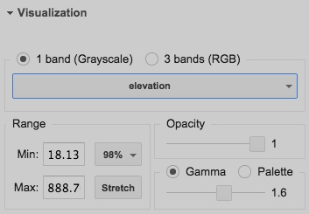

To specify which bands of a multi-band layer are to be depicted as red, green, or blue

in a color composite, use

these controls.

To control the translucency

of a layer, use this slider bar.

To skew the current range of

To specify the value to be colors, click on the **Gamma**

associated with the low end of button, and use this slider bar.

the current color range, use this **Min** field.

Lower values will then be depicted in the color

ascribed to that value. The same can be done

for a maximum value by using this **Max** field. By clicking on **Palette** rather

than **Gamma**, you can access

To indicate the range of values to which the these controls with which you

current range of colors is to be applied by compose ranges of colors specifying the extent of that range above and include more than a single hue.

below its mean, select from on of the options

that will be presented when you click on this button.

Or to limit the range of values that are to be represented by the current range

of colors to whatever values are currently appearing in the Display Screen, click here.

[GOOGLE EARTH ENGINE](EE01%20Earth%20Engine%20(EE).docx) [GRAPHICAL USER INTERFACE](EE02%20%20%20The%20EE%20GUI.docx)

**CAPABILITIES**FOR THE **PRESENTATION** OF DATA LAYERS

A classified raster layer is one whose values represent distinct qualities (such as types of land cover) rather than continuous quantities (such as topographic elevations).

To adjust the display of classified raster layers, you must first establish as a set of what are called “classes.” Each is a specified color and name that can be used to represent any of the values on one or more classified raster layers.

For example, a class whose name is given as “Water” and whose color is set to a particular shade of blue might be assigned to whatever values represents water bodies on one layer entitled “Landcover” and another entitled “Soils.” Significantly, pixels with values for which no class has been designated will always appear as transparent on the **Display Screen**.

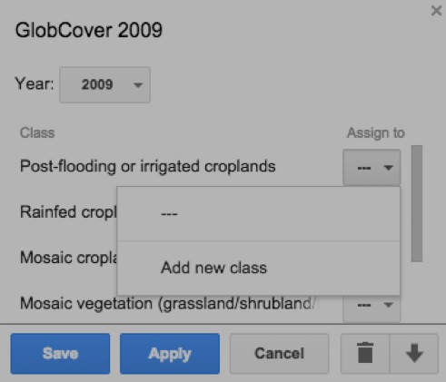To create a new class, you must first add a classified raster to the **Workspace** page

and use its **Layer Settings** dialog box to associate at least one of the listed conditions

it depicts with a new class. To do so,

- click here to the right of any of those conditions,

- then here to create a new class for that condition, and

- then here to retain these settings, close the **Layer Settings** box,

and thereby turn on the **Control Panel** section called **Classes**.

The new class’s name can then

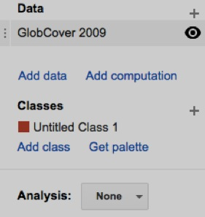 be changed by clicking and editing here.

 or on the pencil button.

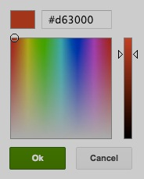

And by clicking on the class’s color box,

a new color can also be chosen for

the class from a color-selection box like

this. *(Note, however, that a change in the*

*color of a condition’s class will be noted only*

*after that class is reassigned to the condition.)*



Additional classes can be added

The **Classes** section will appear

in the **Control Panel** only when

at least one classified raster layer

is present in the **Workspace**.

Whenever the **Classes** section

disappears (for lack of such a layer)

and then reappears (when one is

later added), however, its most

recent state will be restored.

by clicking on either of these two buttons,

and each can be deleted with its **X** button.

The set of colors associated with all

of the classes established for a particular

workspace is referred to as the workspace’s “palette,” and this **Get Pallette** button

can be used to present that palette by listing the numerical identifiers for each of its colors.

[GOOGLE EARTH ENGINE](EE01%20Earth%20Engine%20(EE).docx) [GRAPHICAL USER INTERFACE](EE02%20%20%20The%20EE%20GUI.docx)

**CAPABILITIES**FOR THE **REPRODUCTION** OF DATA LAYERS

Among the **reproduction** capabilities of the EE GUI are those that download data associated with (added or computed) layers on the Workspace page.

The EE GUI can be used to download a file representing a specified portion of a specified layer that is currently depicted on the Workspace page’s Display Screen. Significantly, this capability is available not only for layers representing datasets drawn from the Data Catalog but also for layers computed from such datasets.

It is available, however, only to authorize users. To download a layer’s data, click its name on the Workspace page and then on this **Download layer** button n its Layer Settings dialog box.

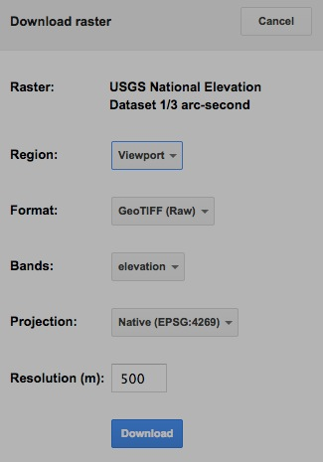

This will open a

**Download raster**

dialog box in which

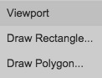- the **Region** to be downloaded can be set to encompass

the **Viewport** (Display Screen), a **Draw**n **Rectangle**, or a **Draw**n **Polygon**;

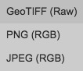

- the **Format** of the file to be downloaded

can be set to **GeoTIF**, **PNG**, or **JPG**;

- the **Bands** to be downloaded

can be selected;

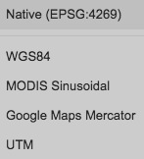

- the **Projection** of the downloaded image can be set to

**Native**, **WGS84**, **MODIS Sinusoidal**, **Google Maps Mercator**, or **UTM**;

- the **Resolution** of the downloaded image

(in meters) can be specified; and

- this **Download** button will initiate the data transfer.